FIP Assignment (B200048A)

# Convolution

Input:

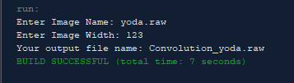

Output:

yoda.raw (original image) Convolution_yoda.raw (3x3)

Convolution2_yoda.raw (5x5)

# Halftoning

Input:

# 

Output:

yoda.raw (original image) Patterning_yoda.raw

Dithering2_yoda.raw(4x4) Dithering_yoda.raw(2x2)

# High Pass Filter

Input:

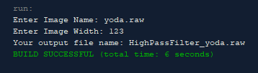

Output:

yoda.raw (original image) HighPassFiler_yoda.raw

# Mean Filter (Low Pass Filter)

Input:

Output:

yoda.raw (original image) MeanFilter_yoda.raw

# Histogram Equalization

Input:

……….

Output:

yoda.raw (original image) Enhance_yoda.raw

# Read Tif File

Input:



